Manual Test Plan

Test 1: maze2

- Select maze2 from the left hand panel. The screenshot should be like this.
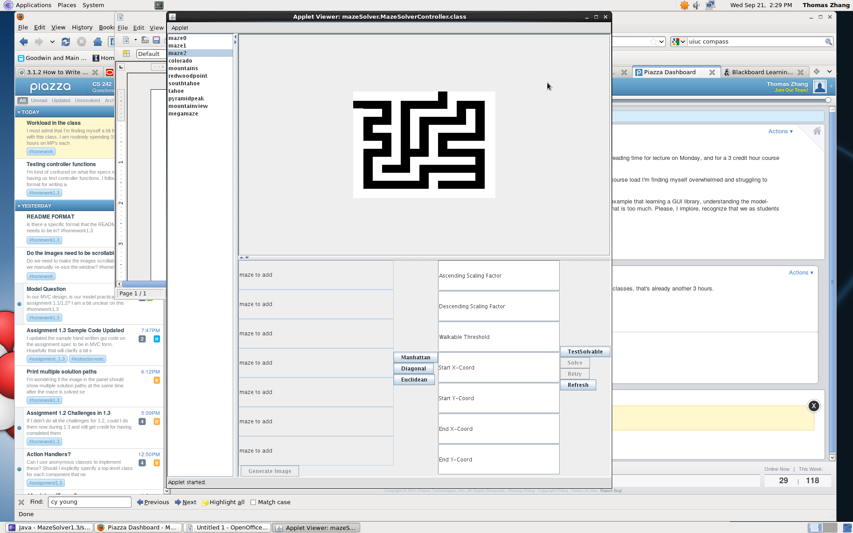
- Click on “Manhattan”.
- Set the Ascending Scaling Factor to 150. Press enter.
- Set the Descending Scaling Factor to 60. Press enter.
- Set the Walkable Threshold to 255. Press enter.
- Set the Start X-Coord to 0. Press enter.
- Set the Start Y-Coord to 30. Press enter.
- Set the End X-Coord to 210. Press enter.
- Set the End Y-Coord to 0. Press enter.
- Click TestSolvable.
- Click Solve. The image should change to this.
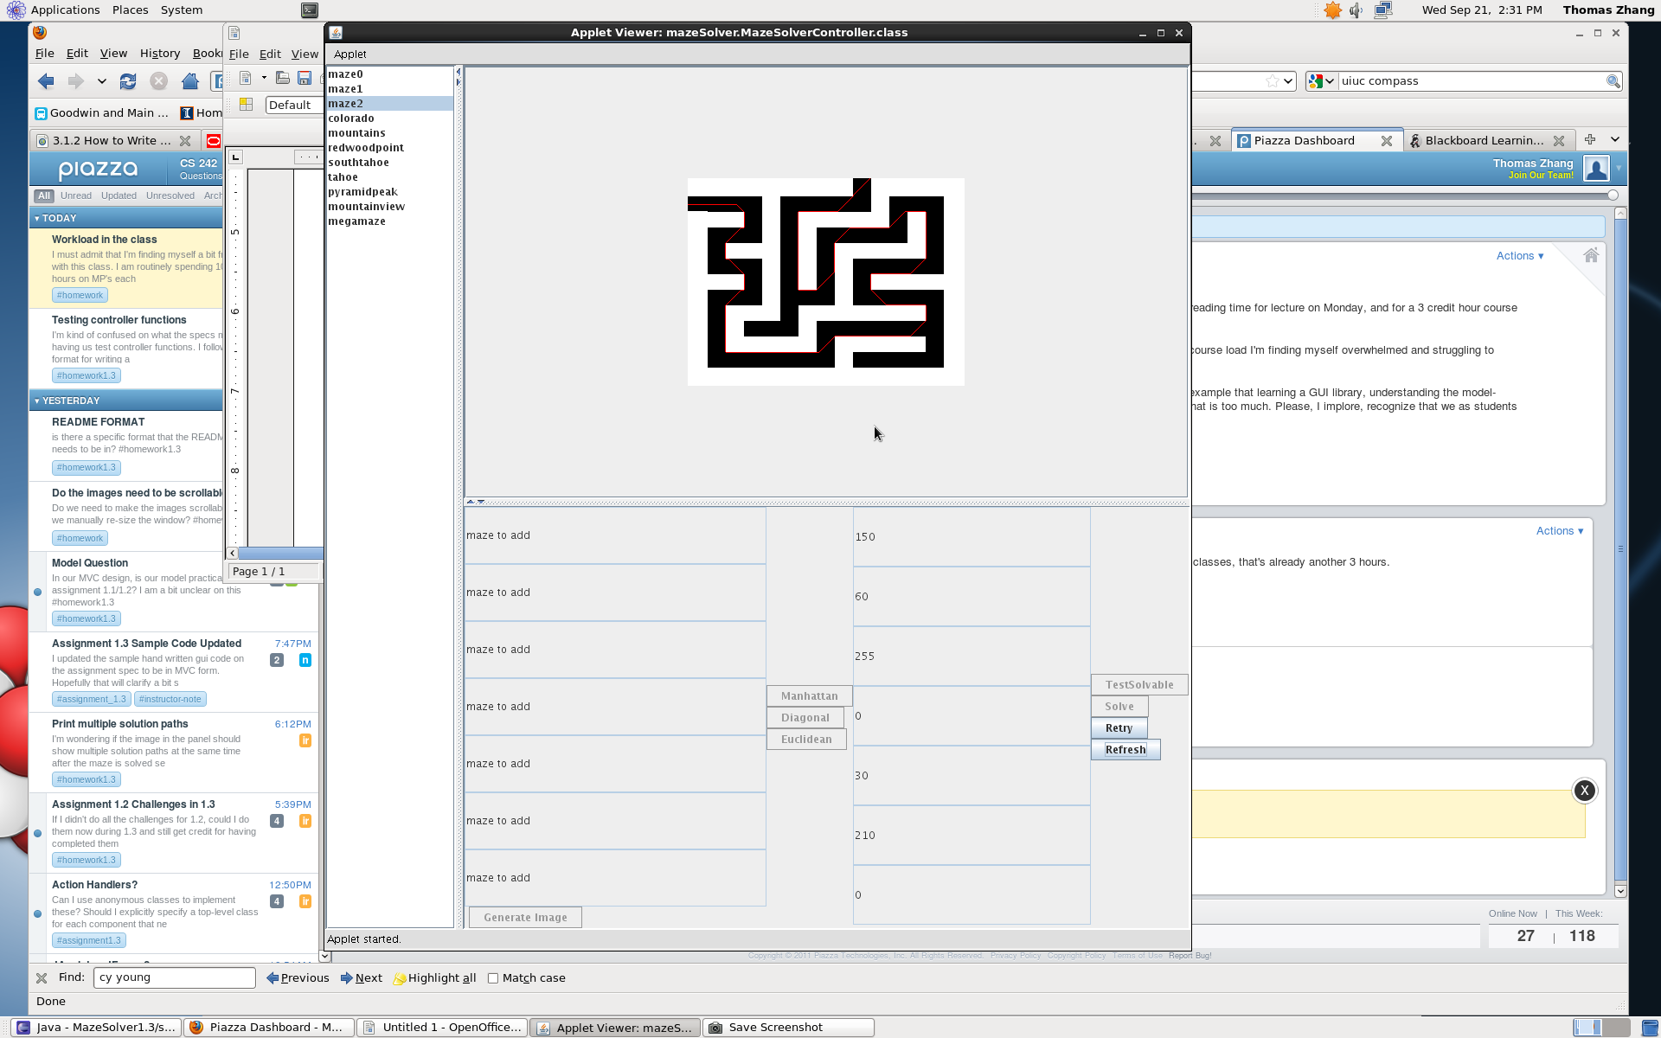
- Click refresh.
Test 2: colorado

- Click on colorado on the left panel. The screenshot should look like this.
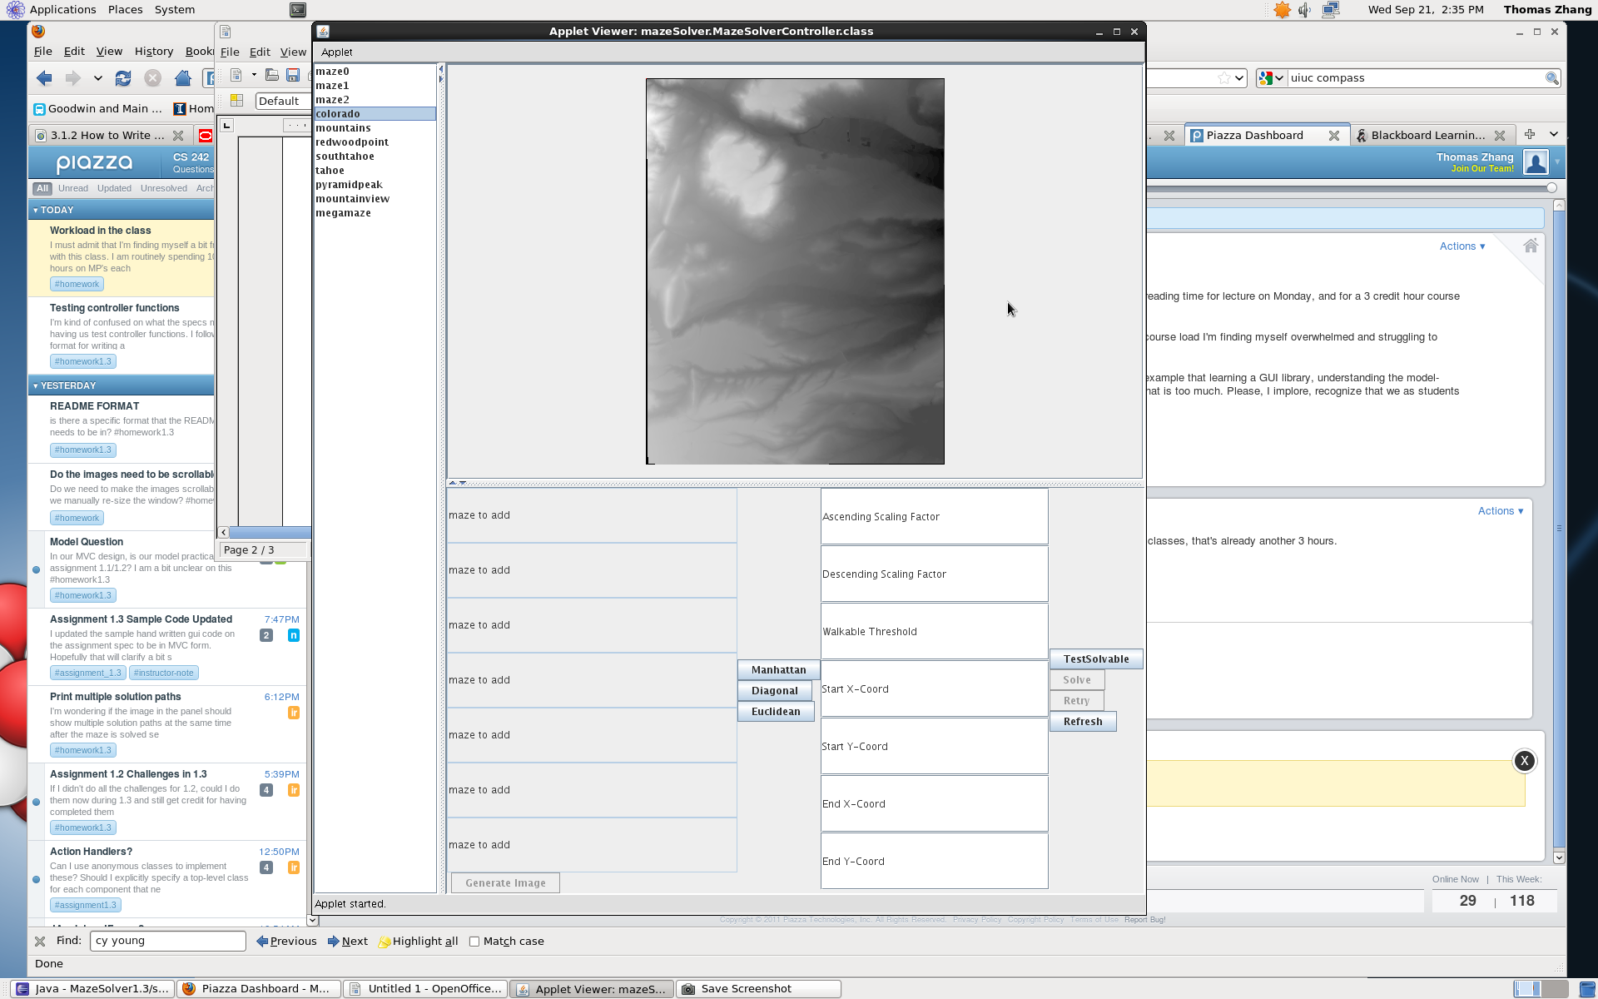
- Click Euclidean.
- Set the Ascending Scaling Factor to 150. Press enter.
- Set the Descending Scaling Factor to 60. Press enter.
- Set the Walkable Threshold to 300. Press enter.
- Set the Start X-Coord to 20. Press enter.
- Set the Start Y-Coord to 20. Press enter.
- Set the End X-Coord to 355. Press enter.
- Set the End Y-Coord to 455. Press enter.
- Click TestSolvable.
- Click Solve. The image should change to this.
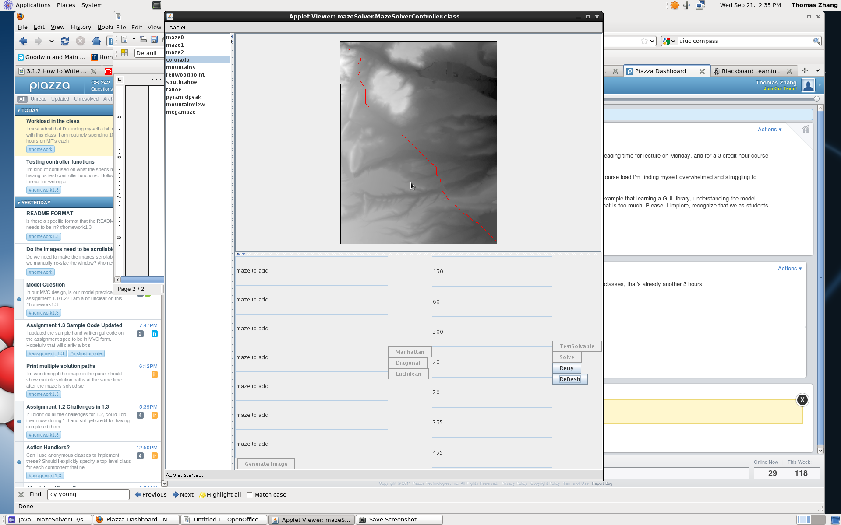
Test2: cont on next page

- Click retry.
- Set the Start X-Coord to 355 Press enter.
- Set the Start Y-Coord to 20. Press enter.
- Set the End X-Coord to 20. Press enter.
- Set the End Y-Coord to 455. Press enter.
- Click TestSolvable.
- Click Solve. The image should change to this.
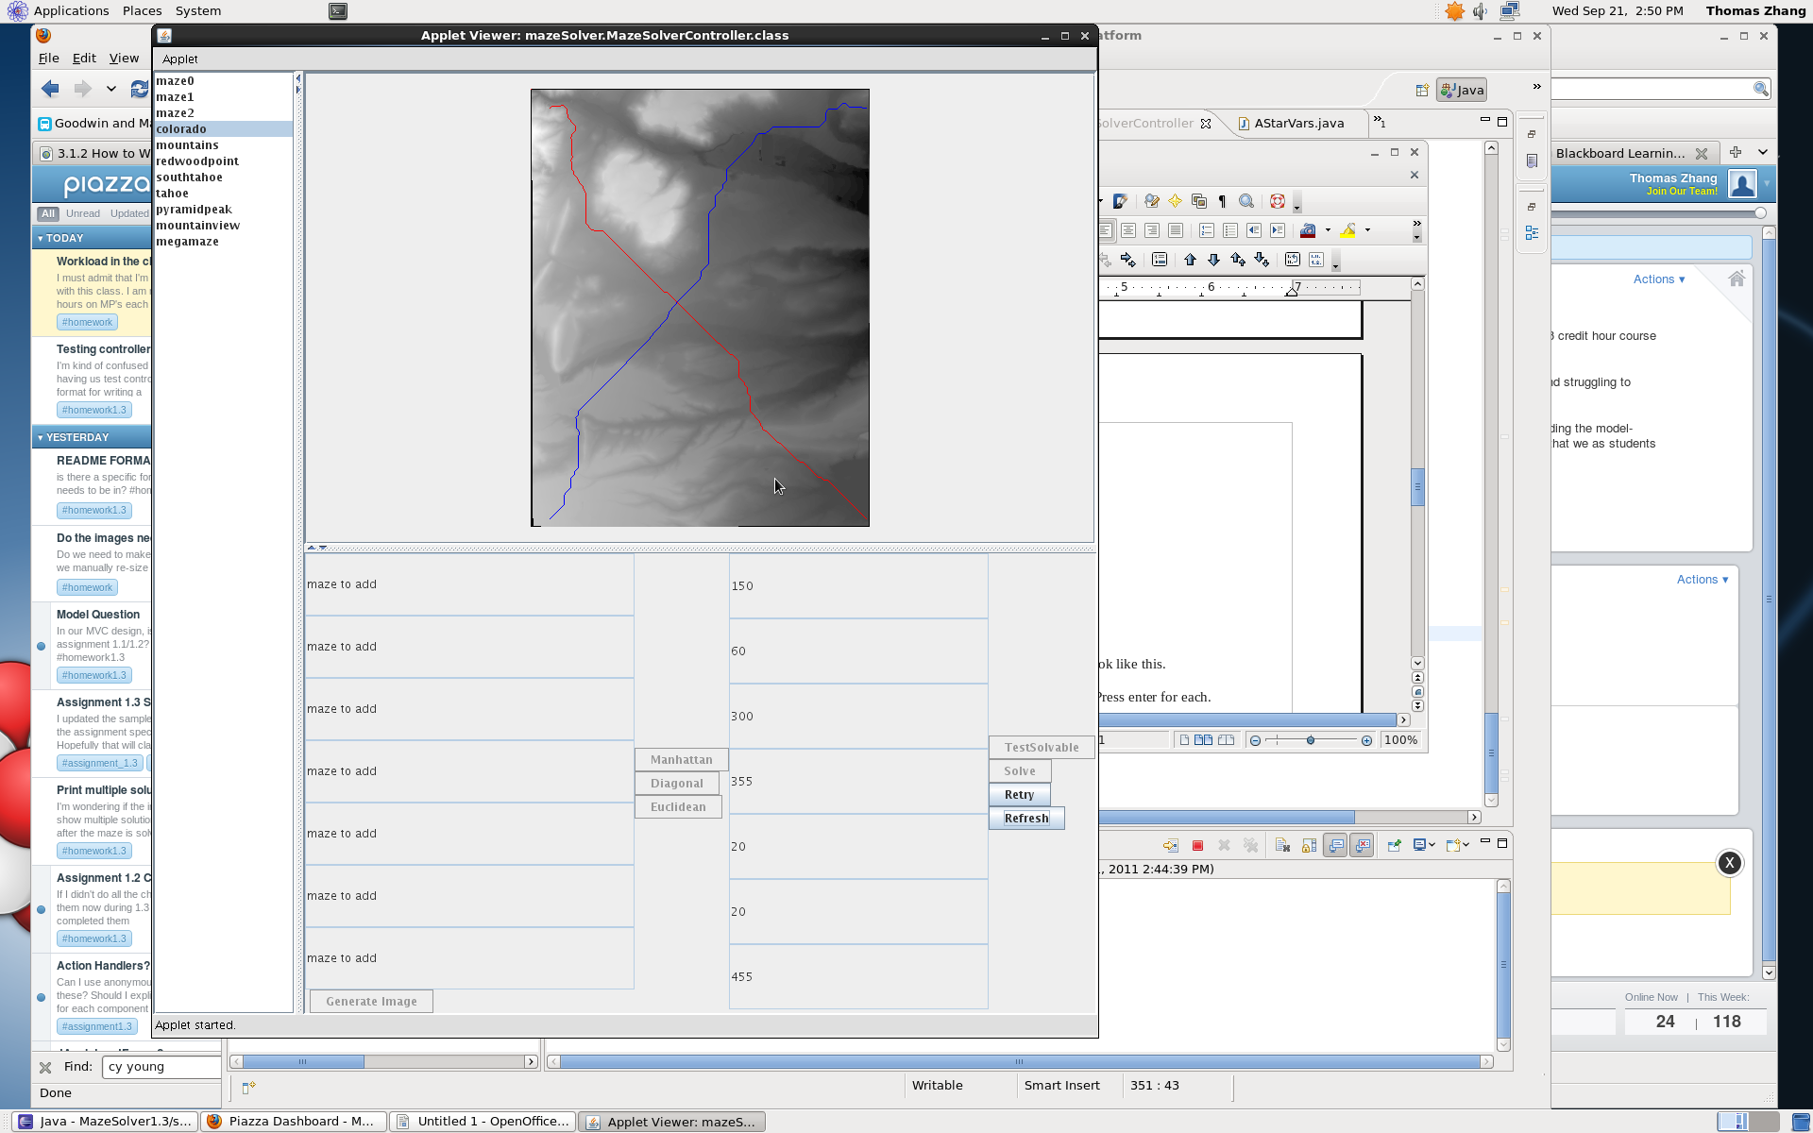

Test 3: megamaze

- Click on megamaze on the left panel. The screenshot should look like this.

- Type the seven mazes to add from colorado to mountainview. Press enter for each.
- Click Generate Image. The image should now change to this.
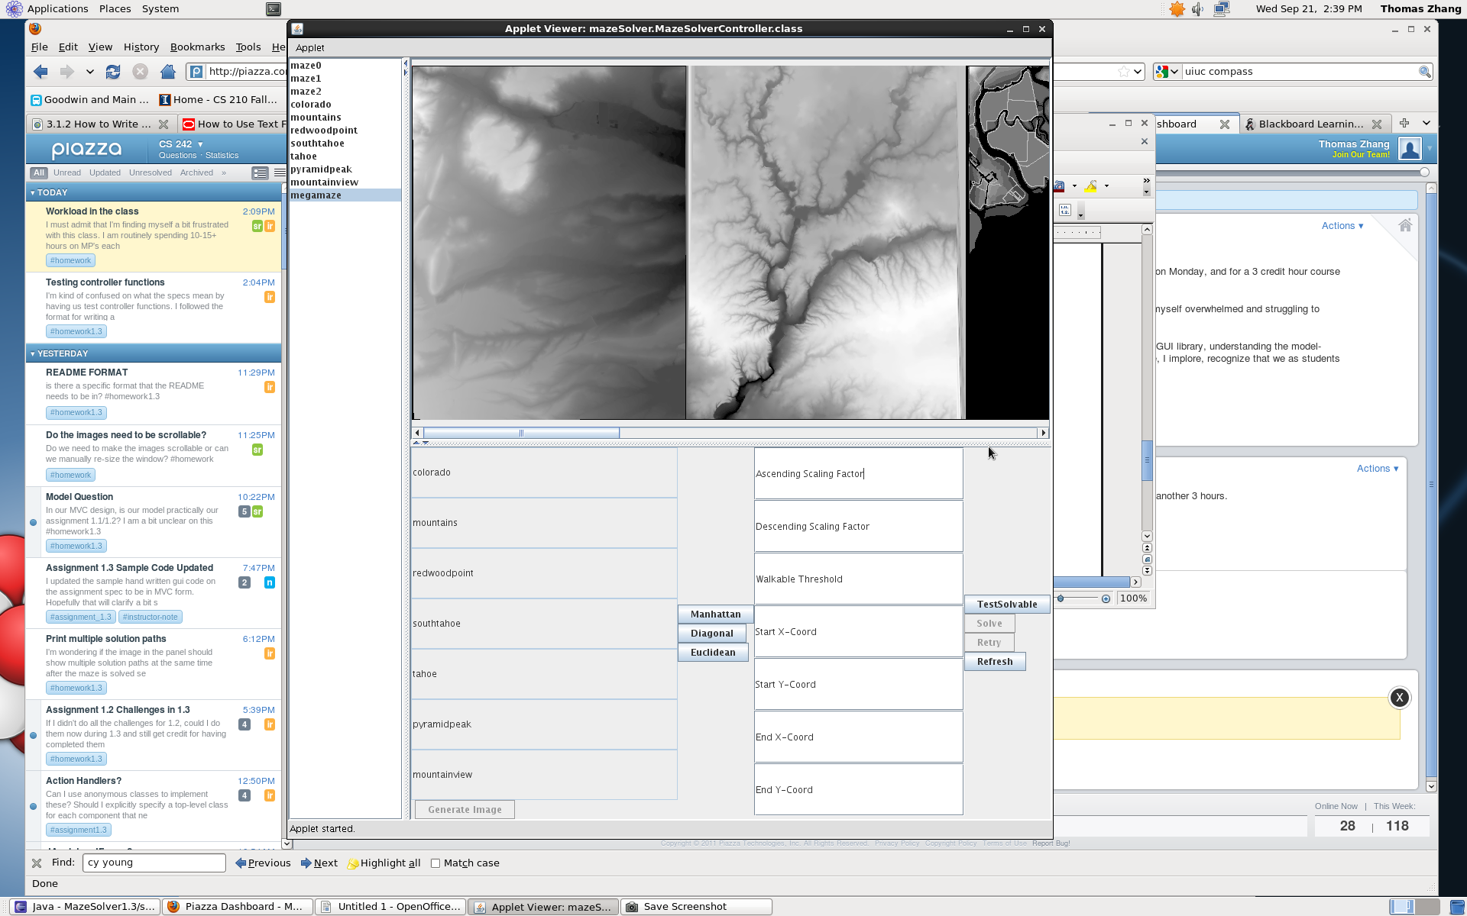
- Click Euclidean.
- Set the Ascending Scaling Factor to 150. Press enter.
- Set the Descending Scaling Factor to 60. Press enter.
- Set the Walkable Threshold to 300. Press enter.
- Set the Start X-Coord to 20. Press enter.
- Set the Start Y-Coord to 20. Press enter.
- Set the End X-Coord to 2550. Press enter.
- Set the End Y-Coord to 455. Press enter.
- Click TestSolvable. Wait until the solve button appears.
- Click Solve. The image should change to this.
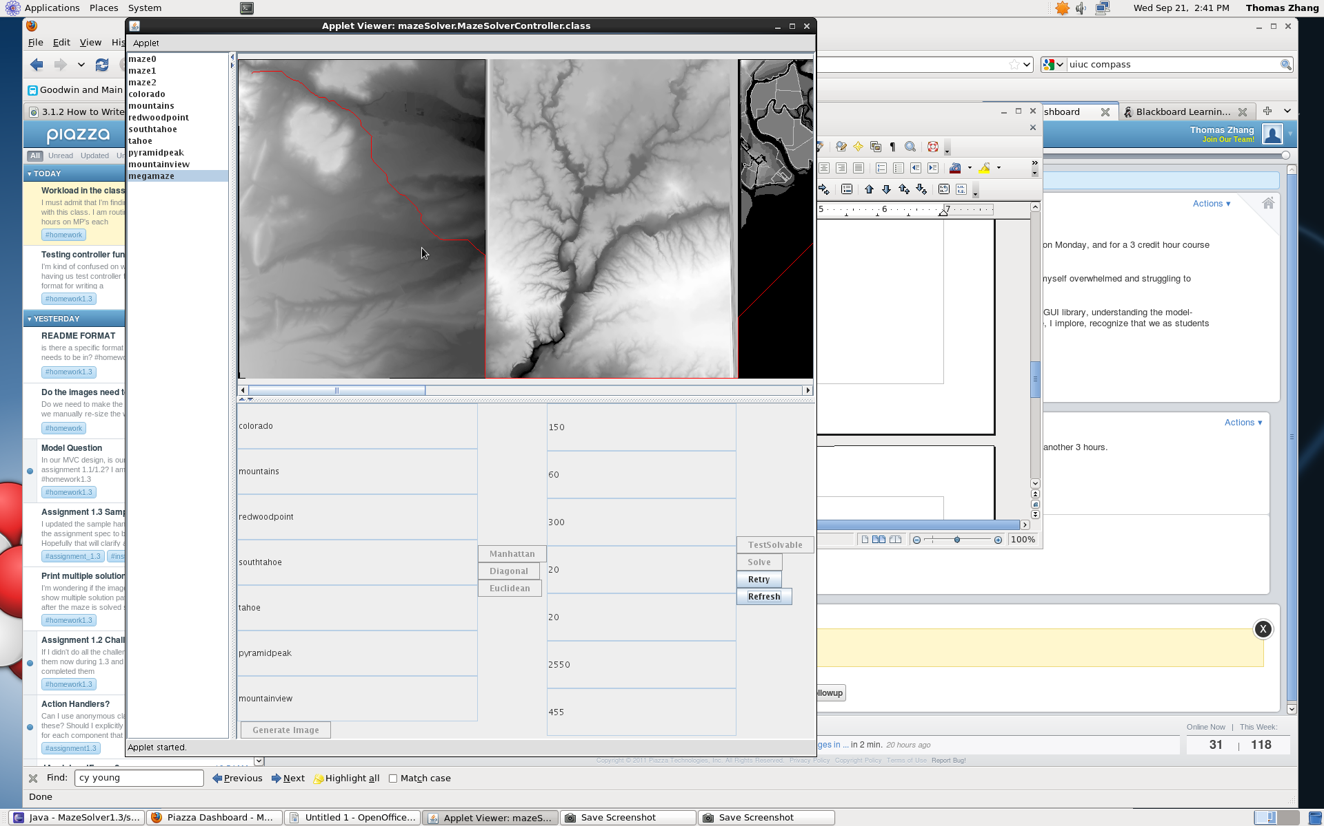
- Click refresh.

